

­­­

**­**

**Submitted By:**

Eisha Kamran SP21-BCS-018

Hafif Ashiq SP21-BCS-023

Mujtaba Tahir SP21-BCS-046

**Submitted To:**

Sir. Inayat Ur Rehman

­

**DSA**

Department of Computer Science

Comsats University Islamabad

**Tele-communication System**

1. **Introduction**

The Tele-Communication System works as a source to connect to users with the help of a network of towers across which the signals travel. This System allows the addition of customers to network forming it a representation of real-world telecommunication network.

The Main Idea behind the project is to form a system similar to the latest technologies of telecommunication to present a model of how these works and also to implement the data structures in the best approach available in a system.

1. **Modules**

Some of the modules are discussed below:

* + 1. **Add or Remove Contacts**

Users can add or delete the Customers in the System and store the information of each customer. For this purpose, linked list has been used and all of the customers are stored using dynamic memory. The Linked list is used instead of BST because it can be traversed and searched based on different entities in a structure.

* + 1. **Contacts**

Like our mobile phones, this system has the contacts list to ensure that the phone numbers of your loved ones are never missed and hypothetically, they are stored in cloud or are linked to the main node of structure of that individual itself. BST is used as one can have hundreds of phone contacts which can be easily searched.

* + 1. **Calls**

The user can call the other user hypothetically (As networking is not used ) and the duration is calculated of the call according to which the cost is deducted at the end of the call based on duration and the difference between both callers.

* + 1. **Messages**

The Messages are stored in form of a queue and new messages can be read directly from the messages panel. Moreover, you can send the message to other user easily and they’ll receive it just the way you sent it.

* + 1. **View Information**

Admin can view all the information of the users and has tendency to add the balance to any user acting like a communication center franchise and also the deletion of a user is possible but only by the admin.

* + 1. **Balance Deduction**

The balance is to be deducted on the basis of call duration and the charges defined along-with the distances between the two users connecting each other and finding the shortest path between two points in a graph easily.

1. **Data Structures**

Our application consists of following data structures:

* Linked list (multi-dimensional).
* Binary Search Tree
* Queue.
* Graphs.

1. **Graph Representation**

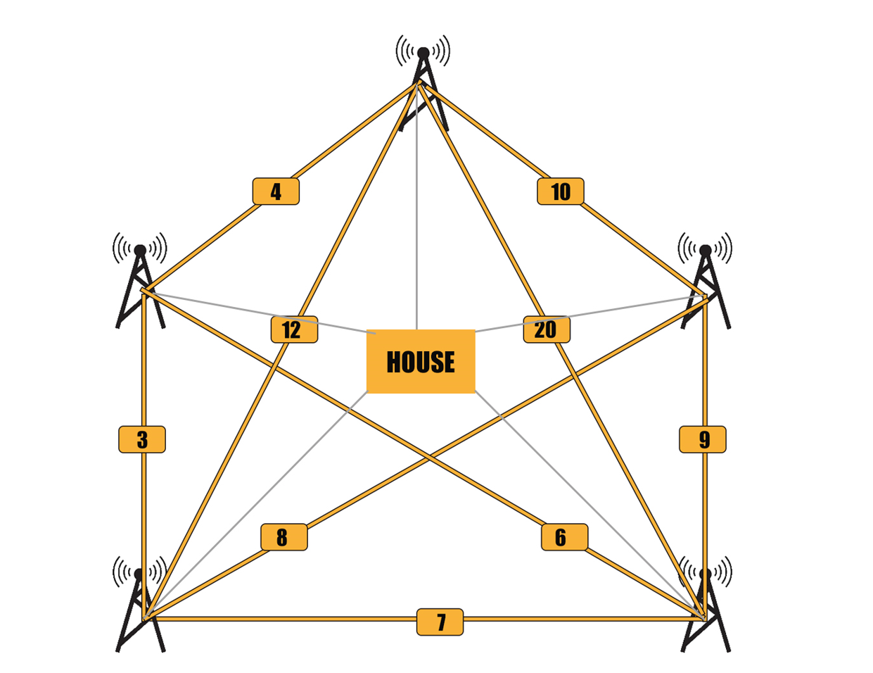

1. **Tools and Technology**

We have used ***C++*** as our main programing language for dealing with all the coding, complexities and data structures in VS Code work environment.